**\*\*\*\*\*\*\*\*\*\* Execute MiniKube & Create Cluster \*\*\*\*\*\*\*\*\*\***

1. minikube start

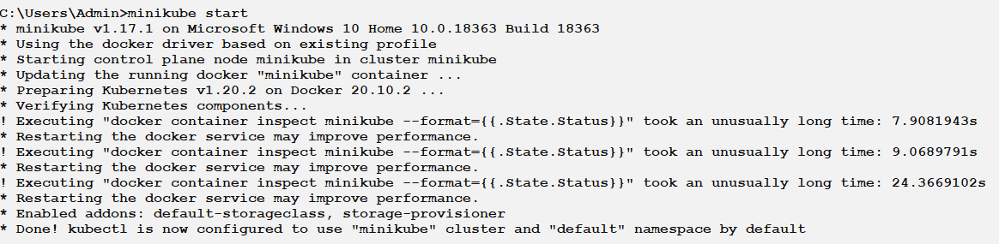

**\*\*\*\*\*\*\*\*\*\* Interact Cluster Using KubeCtl \*\*\*\*\*\*\*\*\*\***

Let’s create a Kubernetes Deployment using an existing image named echo server, which is a simple HTTP server and expose it on port 8080 using --port.

2. kubectl run hello-node --image=k8s.gcr.io/echoserver:1.4 --port=8080

3. kubectl get pod

4. kubectl get deployments

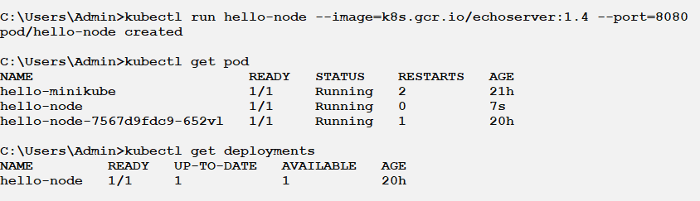

To access the hello-minikube service, we must first expose the deployment to an external IP via the command:

5. kubectl expose deployment hello-node --type=NodePort –port=80

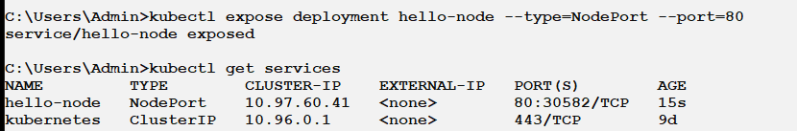

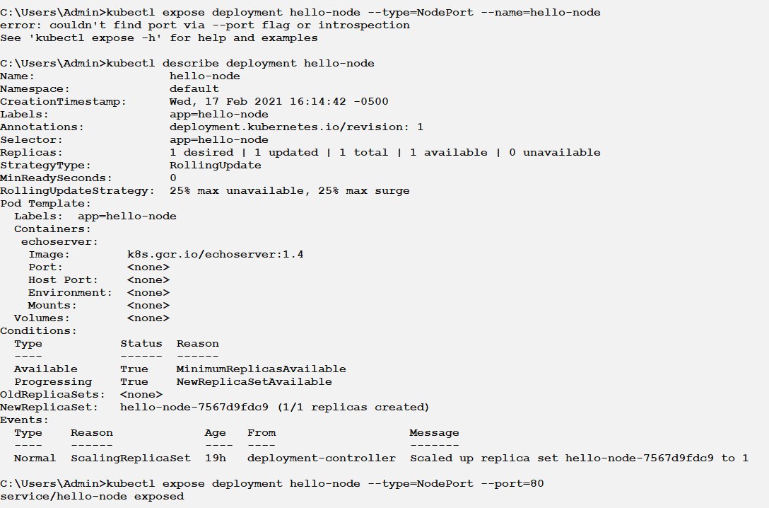

*Create Deployment:

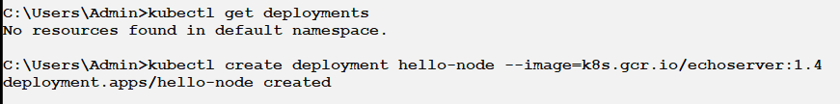

6. kubectl describe deployment hello-node

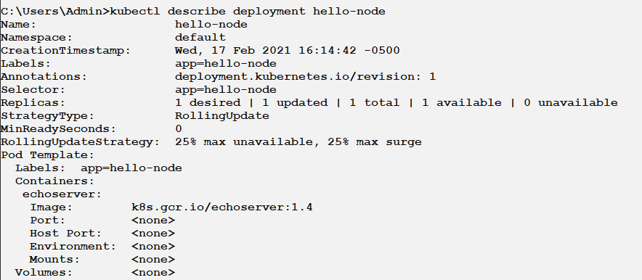

7. kubectl get services.

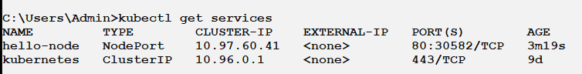

8. minikube service hello-node

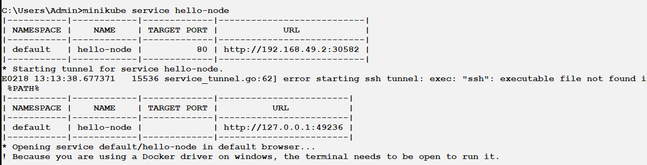

**Delete the Service:**

9. kubectl delete service hello-node

10. kubectl delete deployment hello-node

11. kubectl delete pod hello-node

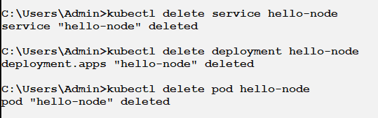

**Stop the local Minikube cluster:**

12. minikube stop

